# **Episode 1: Execution Context**

Everything in JS happens inside the execution context. Imagine a sealed-off container inside which JS runs. It is an abstract concept that hold info about the env. within the current code is being executed.

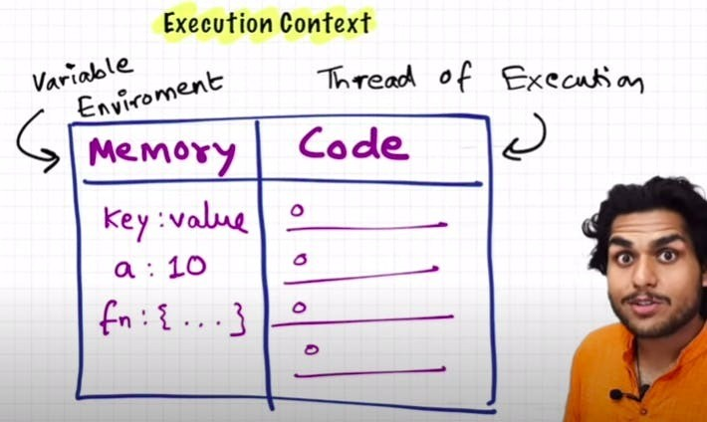

In the container the first component is **memory component** and the 2nd one is **code component**

Memory component has all the variables and functions in key value pairs. It is also called **Variable environment**. Code component is the place where code is executed one line at a time. It is also called the **Thread of Execution**. JS is a **synchronous**, **single-threaded** language

Synchronous: - In a specific synchronous order. Single-threaded: - One command at a time.

# Episode 2: How JS is executed & Call Stack

When a JS program is ran, a **global execution context** is created. The execution context is created in two phases.

Memory creation phase - JS will allocate memory to variables and functions. Code execution phase

Let's consider the below example and its code execution steps:

var n = 2;

function square(num) { var ans = num * num; return ans;

}

var square2 = square(n); var square4 = square(4);

The very **first** thing which JS does is **memory creation phase**, so it goes to line one of above code snippet, and **allocates a memory space** for variable **'n'** and then goes to line two, and **allocates a memory space** for **function 'square'**. When allocating memory **for n it stores 'undefined'**, a special value for 'n'. **For 'square', it stores the whole code of the function inside its memory space.** Then, as square2 and square4 are variables as well, it allocates memory and stores 'undefined' for them, and this is the end of first phase i.e. memory creation phase.

So O/P will look something like

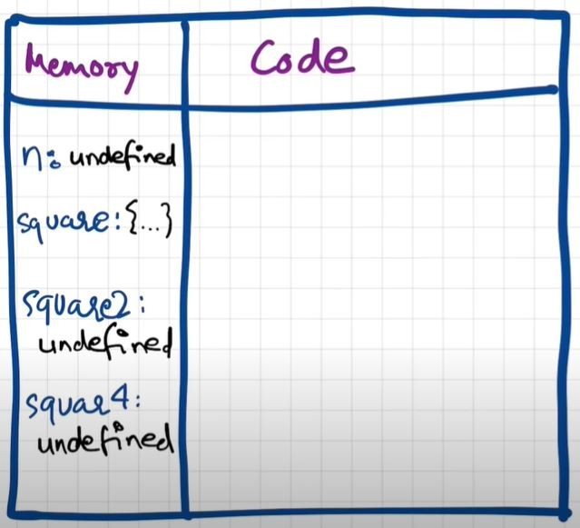

Now, in **2nd phase** i.e. code execution phase, it starts going through the whole code line by line. As it encounters var n = 2, it assigns 2 to 'n'. Until now, the value of 'n' was undefined. For function, there is nothing to execute. As these lines were already dealt with in memory creation phase.

Coming to line 6 i.e. **var square2 = square(n)**, here **functions are a bit different than any other language. A new execution context is created altogether.** Again in this new execution context, in memory creation phase, we allocate memory to num and ans the two variables. And undefined is placed in them. Now, in code execution phase of this execution context, first 2 is assigned to num. Then var ans = num * num will store 4 in ans. After that, return ans returns the control of program back to where this function was invoked from.

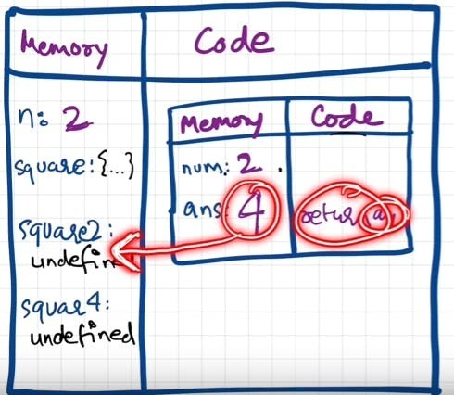

When **return** keyword is encountered, It returns the control to the called line and also **the function execution context is deleted**. Same thing will be repeated for square4 and then after that is finished, the global execution context will be destroyed. So the **final diagram** before deletion would look something like:

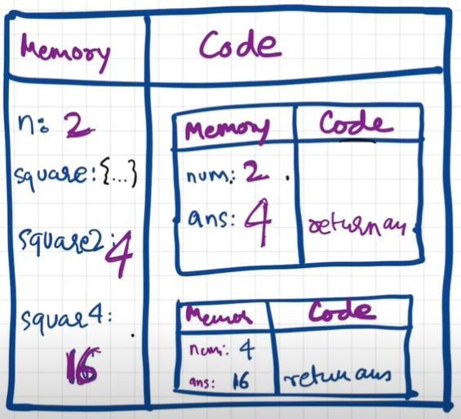

JavaScript manages code execution context creation and deletion with the help of **Call Stack**. Call Stack is a mechanism to keep track of its place in script that calls multiple function.

Call Stack maintains the order of execution of execution contexts. It is also known as Program Stack, Control Stack,

Runtime stack, Machine Stack, Execution context stack.

# Episode 3: Hoisting in JavaScript (variables & functions)

Let's observe the below code and it's explanation:

getName(); // Namaste JavaScript console.log(x); // undefined

var x = 7;

function getName() {

console.log ("Namaste JavaScript");

}

It should have been an outright error in many other languages, as it is not possible to even access something which is not even created (defined) yet but in JS, we know that in memory creation phase it assigns undefined and puts the content of function to function's memory. And in execution, it then executes whatever is asked. Here, as execution goes line by line and not after compiling, it could only print undefined and nothing else. This phenomenon, is not an error. However, if we remove var x = 7; then it gives error. Uncaught Reference Error: x is not defined

**Hoisting** is a concept which enables us to extract values of variables and functions even before initializing/assigning value without getting error and this is happening due to the 1st phase (memory creation phase) of the Execution Context.

So in previous lecture, we learnt that execution context gets created in two phase, so even before code execution, memory is created so in case of variable, it will be initialized as undefined while in case of function the whole function code is placed in the memory. Example:

getName(); // Namaste JavaScript

console.log(x); // Uncaught Reference: x is not defined.

console.log(getName); // f getName(){ console.log("Namaste JavaScript); } function getName() {

console.log ("Namaste JavaScript");

}

Now let's observe a different example and try to understand the output.

getName(); // Uncaught TypeError: getName is not a function console.log(getName);

var getName = function () {

console.log ("Namaste JavaScript");

};

// The code won't execute as the first line itself throws an TypeError.

# Episode 4: Functions and Variable Environments

var x = 1; a();

b(); // we are calling the functions before defining them. This will work properly, as seen in Hoisting.

console.log(x);

function a() {

var x = 10; // local scope because of separate execution context console.log(x);

}

function b() { var x = 100;

console.log(x);

}

Outputs:

10

100

1

## Code Flow in terms of Execution Context

The Global Execution Context (GEC) is created (the big box with Memory and Code subparts). Also GEC is pushed into Call Stack

Call Stack: GEC

In first phase of GEC (memory phase), variable x: undefined and a and b have their entire function code as value initialized

In second phase of GEC (execution phase), when the function is called, a new local Execution Context is created. After x = 1 assigned to GEC x, a() is called. So local EC for a is made inside code part of GEC.

Call Stack: [GEC, a()]

For local EC, a totally different x variable assigned undefined (x inside a()) in phase 1 , and in phase 2 it is assigned 10 and printed in console log. After printing, no more commands to run, so a() local EC is removed from both GEC and from Call stack

Call Stack: GEC

Cursor goes back to b() function call. Same steps repeat.

Call Stack:[GEC, b()] -> GEC (after printing yet another totally different x value as 100 in console log)

Finally, GEC is deleted and also removed from call stack. Program

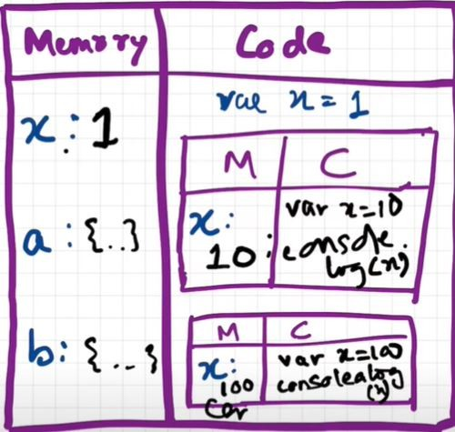

# Episode 5: Shortest JS Program, window & this keyword

eg:

var x = 10;

console.log(x); // 10

console.log(this.x); // 10

console.log(window.x); // 10

The shortest JS program is empty file. Because even then, JS engine does a lot of things. As always, even in this case, it creates the GEC which has memory space and the execution context.

JS engine creates something known as '**window**'. It is an object, which is created in the global space. It contains lots of functions and variables. These functions and variables can be accessed from anywhere in the program. JS engine also creates thiskeyword, which points to the **window object** at the global level. So, in summary, along with GEC, a global object (window) and this variable are created.

In different engines, the name of global object changes. Window in browsers, but in nodeJS it is called something else. At global level, this === window

If we create any variable in the global scope, then the variables get attached to the global object.

# Episode 6: undefined vs not defined in JS

In first phase (memory allocation) JS assigns each variable a placeholder called **undefined**. **undefined** is when memory is allocated for the variable, but no value is assigned yet.

If an object/variable is not even declared/found in memory allocation phase, and tried to access it then it is **Not defined**

Not Defined! == Undefined

When variable is declared but not assigned value, its current value is **undefined**. But when the variable itself is not declared but called in code, then it is **not defined**.

console.log(x); // undefined var x = 25;

console.log(x); // 25

console.log(a); // Uncaught Reference Error: a is not defined

JS is a **loosely typed / weakly typed** language. It doesn't attach variables to any datatype. We can say *var a = 5*, and then change the value to boolean *a = true* or string *a = 'hello'* later on.

**Never** assign *undefined* to a variable manually. Let it happen on its own accord.

# Episode 7: The Scope Chain, Scope & Lexical Environment

**Scope** in JavaScript is directly related to **Lexical Environment**. Let's observe the below examples:

// CASE 1

function a() {

console.log(b); // 10

// Instead of printing undefined it prints 10, So somehow this a function could access the variable b outside the function scope.

}

var b = 10; a();

// CASE 2

function a() { c();

function c() {

console.log(b); // 10

}

}

var b = 10; a();

// CASE 3

function a() { c();

function c() { var b = 100;

console.log(b); // 100

}

}

var b = 10; a();

// CASE 4

function a() { var b = 10; c();

function c() {

console.log(b); // 10

}

}

a();

console.log(b); // Error, Not Defined

Let's try to understand the output in each of the cases above.

In **case 1**: function a is able to access variable b from Global scope.

In **case 2**: 10 is printed. It means that within nested function too, the global scope variable can be accessed. In **case 3**: 100 is printed meaning local variable of the same name took precedence over a global variable. In **case 4**: A function can access a global variable, but the global execution context can't access any local variable.

To summarize the above points in terms of execution context: call stack = [GEC, a(), c()]

Now lets also assign the memory sections of each execution context in call stack. c() = [[lexical environment pointer pointing to a()]]

a() = [b:10, c:{}, [lexical environment pointer pointing to GEC]] GEC = [a:{},[lexical environment pointer pointing to null]]

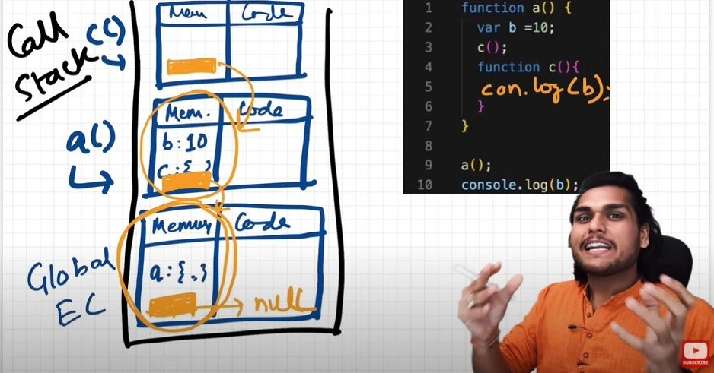

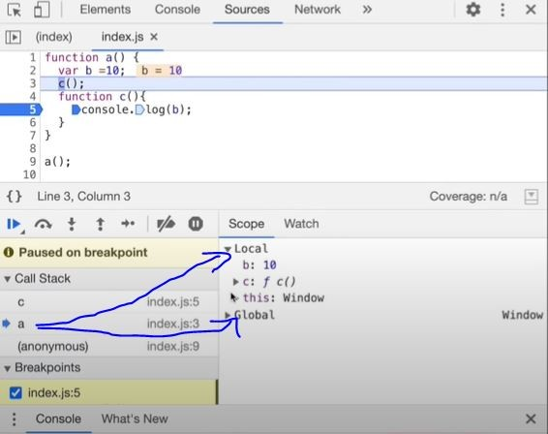

So, **Lexical Environment** = local memory + lexical env of its parent. Hence, Lexical Environement is the local memory along with the lexical environment of its parent

**Lexical**: In hierarchy, In order

Whenever an Execution Context is created, a Lexical environment(LE) is also created and is referenced in the local Execution Context(in memory space).

The process of going one by one to parent and checking for values is called scope chain or Lexcial environment chain.

function a() { function c() {

// logic here

}

c(); // c is lexically inside a

} // a is lexically inside global execution

Lexical or Static scope refers to the accessibility of variables, functions and object based on physical location in source code.

Global {

Outer {

Inner

}

}

// Inner is surrounded by lexical scope of Outer

**TLDR**; An inner function can access variables which are in outer functions even if inner function is nested deep. In any other case, a function can't access variables not in its scope.

# Episode 8: let & const in JS, Temporal Dead Zone

let and const declarations are hoisted. But its different from **var**

console.log(a); // ReferenceError: Cannot access 'a' before initialization console.log(b); // prints undefined as expected

let a = 10;

console.log(a); // 10 var b = 15;

console.log(window.a); // undefined console.log(window.b); // 15

It looks like let isn't hoisted, **but it is**, let's understand

Both a and b are actually initialized as *undefined* in hoisting stage. But var **b** is inside the storage space of GLOBAL, and **a** is in a separate memory object called script, where it can be accessed only after assigning some value to it first ie. one can access 'a' only if it is assigned. Thus, it throws error.

**Temporal Dead Zone** : Time since when the let variable was hoisted until it is initialized some value.

So any line till before "let a = 10" is the TDZ for a

Since a is not accessible on global, its not accessible in *window/this* also. window.b or this.b -> 15; But window.a or this.a ->undefined, just like window.x->undefined (x isn't declared anywhere)

**Reference Error** are thrown when variables are in temporal dead zone.

**Syntax Error** doesn't even let us run single line of code.

let a = 10;

let a = 100; //this code is rejected upfront as SyntaxError. (duplicate declaration)

let a = 10;

var a = 100; // this code also rejected upfront as SyntaxError. (can't use same name in same scope)

**Let** is a stricter version of **var**. Now, **const** is even more stricter than **let**.

let a; a = 10;

console.log(a) // 10. Note declaration and assigning of a is in different lines.

const b; b = 10;

console.log(b); // Syntax Error: Missing initializer in const declaration. (This type of declaration won't work with const. const b = 10 only will work)

const b = 100;

b = 1000; //this gives us Type Error: Assignment to constant variable.

Types of **Error**: Syntax, Reference, and Type.

Uncaught Reference Error: x is not defined at ...

This Error signifies that x has never been in the scope of the program. This literally means that x was never defined/declared and is being tried to be accessed.

Uncaught Reference Error: cannot access 'a' before initialization

This Error signifies that 'a' cannot be accessed because it is declared as 'let' and since it is not assigned a value, it is its Temporal Dead Zone. Thus, this error occurs.

Uncaught Syntax Error: Identifier 'a' has already been declared

This Error signifies that we are re-declaring a variable that is 'let' declared. No execution will take place.

Uncaught Syntax Error: Missing initializer in const declaration

This Error signifies that we haven't initialized or assigned value to a const declaration.

Uncaught Type Error: Assignment to constant variable

This Error signifies that we are reassigning to a const variable.

### SOME GOOD PRACTICES:

Try using const wherever possible. If not, use let, Avoid var.

Declare and initialize all variables with let to the top to avoid errors to shrink temporal dead zone window to zero.

# Episode 9: Block Scope & Shadowing in JS

What is a **Block**?

Block aka *compound statement* is used to group JS statements together into 1 group. We group them within {...}

{

var a = 10; let b = 20;

const c = 30;

// Here let and const are hoisted in Block scope,

// While, var is hoisted in Global scope.

}

Block Scope and its accessibility example

{

var a = 10;

let b= 20;

const c = 30;

}

console.log(a); // 10

console.log(b); // Uncaught Reference Error: b is not defined

* Reason?
  + In the BLOCK SCOPE; we get b and c inside it initialized as *undefined* as a part of hoisting (in a separate memory space called **block**)
  + While, a is stored inside a GLOBAL scope.
  + Thus we say, *let* and *const* are BLOCK SCOPED. They are stored in a separate mem space which is reserved for this block. Also, they can't be accessed outside this block. But var a can be accessed anywhere as it is in global scope. Thus, we can't access them outside the Block.

What is **Shadowing**?

var a = 100;

{

var a = 10; // same name as global var let b = 20;

const c = 30;

console.log(a); // 10

console.log(b); // 20

console.log(c); // 30

}

console.log(a); // 10, instead of the 100 we were expecting. So block "a" modified val of global "a" as well. In console, only b and c are in block space. a initially is in global space(a = 100), and when a = 10 line is run, a is not created in block space, but replaces

100 with 10 in global space itself.

So, If one has same named variable outside the block, the variable inside the block *shadows* the outside variable.

#### This happens only for var

Let's observe the behavior in case of let and const and understand it's reason.

let b = 100;

{

var a = 10; let b = 20;

const c = 30;

console.log(b); // 20

}

console.log(b); // 100, Both b's are in separate spaces (one in Block(20) and one in

Script(another arbitrary mem space)(100)). Same is also true for *const* declarations.

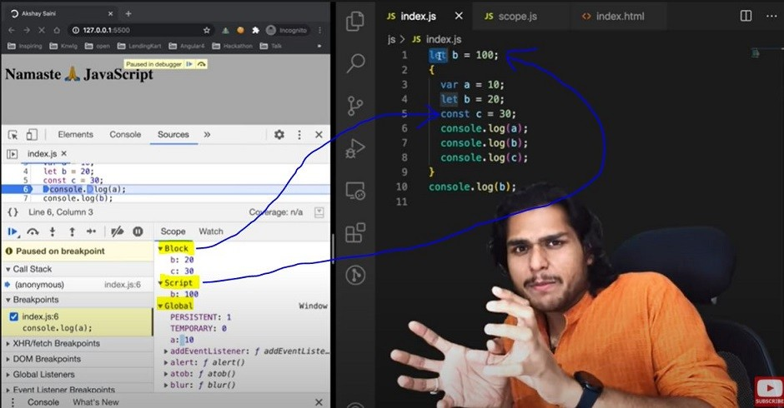

Same logic is true even for **functions**

const c = 100; function x() {

const c = 10;

console.log(c); // 10

}

x();

console.log(c); // 100

What is **Illegal Shadowing**?

let a = 20;

{

var a = 20;

}

// Uncaught Syntax Error: Identifier 'a' has already been declared

We cannot shadow let with var. But it is **valid** to shadow a let using a let. However, we can shadow var with let. All scope rules that work in function are same in arrow functions too.

Since var is function scoped, it is not a problem with the code below.

let a = 20;

function x() { var a = 20;

}

# Episode 10: Closures in JS

Function bundled along with it's lexical scope is **closure**.

JavaScript has a lexcial scope environment. If a function needs to access a variable, it first goes to its local memory. When it does not find it there, it goes to the memory of its lexical parent. See Below code, Over here function **y** along with its lexical scope i.e. (function x) would be called a closure.

function x() { var a = 7;

function y() {

console.log(a);

}

return y;

}

var z = x();

console.log(z); // value of z is entire code of function y.

In above code, when y is returned, not only is the function returned but the entire closure (fun y + its lexical scope) is returned and put inside z. So when z is used somewhere else in program, it still remembers var a

inside x() Another Example

function z() { var b = 900;

function x() { var a = 7;

function y() {

console.log(a, b);

} y();

} x();

}

z(); // 7 900

Thus In simple words, we can say:

**\*A closure is a function** that has access to its outer function scope even after the function has returned. Meaning, A closure can remember and access variables and arguments reference of its outer function even after the function has returned.*

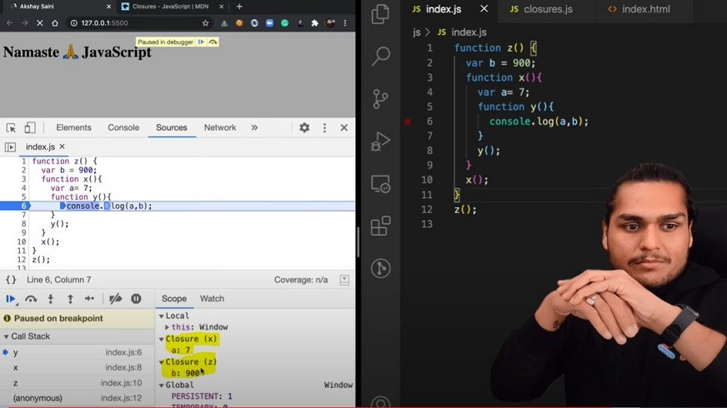

Advantages of Closure:

Certainly! Let's explore examples for each of the advantages you've mentioned:

#### Module Design Pattern:

The module design pattern allows us to encapsulate related functionality into a single module or file. It helps organize code, prevent global namespace pollution, and promotes reusability.

Example: Suppose we're building a web application, and we want to create a module for handling user authentication. We can create a auth.js module that exports functions like login, logout, and

getUserInfo.

// auth.js

const authModule = (function () { let loggedInUser = null;

function login(username, password) {

// Authenticate user logic... loggedInUser = username;

}

function logout() {

loggedInUser = null;

}

function getUserInfo() { return loggedInUser;

}

return { login, logout,

getUserInfo,

};

})();

// Usage

authModule.login('john_doe', 'secret');

console.log(authModule.getUserInfo()); // 'john_doe'

#### Currying:

Currying is a technique where a function that takes multiple arguments is transformed into a series of functions that take one argument each. It enables partial function application and enhances code flexibility.

Example: Let's create a curried function to calculate the total price of items with tax.

const calculateTotalPrice = (taxRate) => (price) => price + price * (taxRate / 100);

const calculateSalesTax = calculateTotalPrice(8); // 8% sales tax const totalPrice = calculateSalesTax(100); // Price with tax

console.log(totalPrice); // 108

#### 2.Memoization:

Memoization optimizes expensive function calls by caching their results. It's useful for recursive or repetitive computations.

Example: Implement a memoized Fibonacci function.

function fibonacci(n, memo = {}) { if (n in memo) return memo[n];

if (n <= 1) return n;

memo[n] = fibonacci(n - 1, memo) + fibonacci(n - 2, memo); return memo[n];

}

console.log(fibonacci(10)); // 55

#### Data Hiding and Encapsulation:

Encapsulation hides the internal details of an object and exposes only necessary methods and properties. It improves code maintainability and security.

Example: Create a Person class with private properties.

class Person {

#name; // Private field

constructor(name) { this.#name = name;

}

getName() {

return this.#name;

}

}

const person = new Person('Alice');

console.log(person.getName()); // 'Alice'

// console.log(person.#name); // Error: Private field '#name' must be declared in an enclosing class

#### set Timeouts:

set Timeout allows scheduling a function to run after a specified delay. It's commonly used for asynchronous tasks, animations, and event handling.

Example: Delayed message display.

function showMessage(message, delay) { setTimeout(() => {

console.log(message);

}, delay);

}

showMessage('Hello, world!', 2000); // Display after 2 seconds

These examples demonstrate the power and versatility of closures in JavaScript! 🚀

Disadvantages of Closure:

Over consumption of memory Memory Leak

Freeze browser

# Episode 11: setTimeout + Closures Interview Question

**Time, tide and JavaScript wait for none.**

function x() { var i = 1;

setTimeout(function () { console.log(i);

}, 3000);

console.log("Namaste JavaScript");

}

x();

// Output:

// Namaste JavaScript

// 1 // after waiting 3 seconds

We expect JS to wait 3 sec, print 1 and then go down and print the string. But JS prints string immediately, waits 3 sec and then prints 1.

The function inside setTimeout forms a closure (remembers reference to i). So wherever function goes it carries this ref along with it.

setTimeout takes this callback function & attaches timer of 3000ms and stores it. Goes to next line without waiting and prints string.

After 3000ms runs out, JS takes function, puts it into call stack and runs it. Q: Print 1 after 1 sec, 2 after 2 sec till 5 : Tricky interview question

We assume this has a simple approach as below

function x() {

for (var i = 1; i <= 5; i++) { setTimeout(function () {

console.log(i);

}, i * 1000);

}

console.log("Namaste Javascript");

}

x();

// Output:

// Namaste Javascript

// 6

// 6

// 6

// 6

// 6

Reason?

This happens because of closures. When setTimeout stores the function somewhere and attaches timer to it, the function remembers its reference to i, **not value of i**. All 5 copies of function point to same reference of i. JS stores these 5 functions, prints string and then comes back to the functions. By then the timer has run fully. And due to looping, the i value became 6. And when the callback fun runs the variable i = 6. So same 6 is printed in each log

To avoid this, we can use **let** instead of **var** as let has Block scope. For each iteration, the i is a new variable altogether (new copy of i). Every time setTimeout is run, the inside function forms closure with new variable i

But what if interviewer ask us to implement using **var**?

function x() {

for (var i = 1; i <= 5; i++) { function close(i) {

setTimeout(function () { console.log(i);

}, i * 1000);

// put the setT function inside new function close()

}

close(i); // everytime you call close(i) it creates new copy of i. Only this time, it is with var itself!

}

console.log("Namaste JavaScript");

}

x();

# Episode 12: Famous Interview Questions ft. Closures

### Q1: What is Closure in Javascript?

**Ans**: A function along with reference to its outer environment together forms a closure. Or in other words, A Closure is a combination of a function and its lexical scope bundled together.

eg:

function outer() { var a = 10;

function inner() { console.log(a);

} // inner forms a closure with outer return inner;

}

outer()(); // 10 // over here first `()` will return inner function and then using second

`()` to call inner function

### Q2: Will the below code still forms a closure?

function outer() { function inner() {

console.log(a);

}

var a = 10;

return inner;

}

outer()(); // 10

**Ans**: Yes, because inner function forms a closure with its outer environment so sequence doesn't matter.

### Q3: Changing var to let, will it make any difference?

function outer() { let a = 10;

function inner() { console.log(a);

}

return inner;

}

outer()(); // 10

**Ans**: It will still behave the same way.

### Q4: Will inner function have the access to outer function argument?

function outer(str) { let a = 10;

function inner() {

console.log(a, str);

}

return inner;

}

outer("Hello There")(); // 10 "Hello There"

**Ans**: Inner function will now form closure and will have access to both a and str.

### Q5: In below code, will inner form closure with **outest**?

function outest() { var c = 20;

function outer(str) { let a = 10;

function inner() {

console.log(a, c, str);

}

return inner;

}

return outer;

}

outest()("Hello There")(); // 10 20 "Hello There"

**Ans**: Yes, inner will have access to all its outer environment.

### Q6: Output of below code and explaination?

function outest() { var c = 20;

function outer(str) { let a = 10;

function inner() {

console.log(a, c, str);

}

return inner;

}

return outer;

}

let a = 100;

outest()("Hello There")(); // 10 20 "Hello There"

**Ans**: Still the same output, the inner function will have reference to inner a, so conflicting name won't matter here. If it wouldn't have find a inside outer function then it would have went more outer to find a and thus have printed 100. So, it try to resolve variable in scope chain and if a wouldn't have been found it would have given reference error.

### Q7: Advantage of Closure?

Module Design Pattern Currying

Memoize

Data hiding and encapsulation setTimeouts etc.

### Q8: Discuss more on Data hiding and encapsulation?

// without closures var count = 0;

function increment(){ count++;

}

// in the above code, anyone can access count and change it.

// (with closures) -> put everything into a function function counter() {

var count = 0;

function increment(){ count++;

}

}

console.log(count); // this will give referenceError as count can't be accessed. So now we are able to achieve hiding of data

//(increment with function using closure) true function function counter() {

var count = 0;

return function increment(){ count++;

console.log(count);

}

}

var counter1 = counter(); //counter function has closure with count var. counter1(); // increments counter

var counter2 = counter();

counter2(); // here counter2 is whole new copy of counter function and it wont impack the output of counter1

*************************

// Above code is not good and scalable for say, when you plan to implement decrement counter at a later stage.

// To address this issue, we use *constructors*

// Adding decrement counter and refactoring code:

function Counter() {

//constructor function. Good coding would be to capitalize first letter of constructor function.

var count = 0;

this.incrementCounter = function() { //anonymous function count++;

console.log(count);

}

this.decrementCounter = function() { count--;

console.log(count);

}

}

var counter1 = new Counter(); // new keyword for constructor fun counter1.incrementCounter();

counter1.incrementCounter(); counter1.decrementCounter();

// returns 1 2 1

### Q9: Disadvantage of closure?

**Ans**: Overconsumption of memory when using closure as everytime as those closed over variables are not garbage collected till program expires. So when creating many closures, more memory is accumulated and this can create memory leaks if not handled.

**Garbage collector** : Program in JS engine or browser that frees up unused memory. In highlevel languages like C++ or JAVA, garbage collection is left to the programmer, but in JS engine its done implicitly.

function a() { var x = 0;

return function b() { console.log(x);

};

}

var y = a(); // y is a copy of b() y();

// Once a() is called, its element x should be garbage collected ideally. But fun b has closure over var x. So mem of x cannot be freed. Like this if more closures formed, it becomes an issue. To tacke this, JS engines like v8 and Chrome have smart garbage

collection mechanisms. Say we have var x = 0, z = 10 in above code. When console log happens, x is printed as 0 but z is removed automatically.

# Episode 13: First Class Functions ft. Anonymous Functions

Functions are heart ♥ of JavaScript.

### Q: What is Function statement?

Below way of creating function are function statement.

function a() {

console.log("Hello");

}

a(); // Hello

### Q: What is Function Expression?

Assigning a function to a variable. Function acts like a value.

var b = function () { console.log("Hello");

}; b();

### Q: Difference between function statement and expression

The major difference between these two lies in **Hoisting**.

a(); // "Hello A" b(); // TypeError function a() {

console.log("Hello A");

}

var b = function () {

console.log("Hello B");

};

// Why? During mem creation phase a is created in memory and function assigned to a. But b is created like a variable (b: undefined) and until code reaches the function() part, it is still undefined. So it cannot be called.

### Q: What is Function Declaration?

Other name for **function statement**.

### Q: What is Anonymous Function?

A function without a name.

function () {

}// this is going to throw Syntax Error - Function Statement requires function name.

They don't have their own identity. So an anonymous function without code inside it results in an error. Anonymous functions are used when functions are used as values eg. the code sample for **function expression** above.

### Q: What is Named Function Expression?

Same as Function Expression but function has a name instead of being anonymous.

var b = function xyz() {

console.log("b called");

};

b(); // "b called"

xyz(); // Throws ReferenceError:xyz is not defined.

// xyz function is not created in global scope. So it can't be called.

### Q: Parameters vs Arguments?

var b = function (param1, param2) {

// labels/identifiers are parameters console.log("b called");

};

b(arg1, arg2); // arguments - values passed inside function call

Q: What is First Class Function also know as First Class Citizens?

We can pass functions inside a function as arguments and /or return a function(HOF). These abilities are altogether known as First class function. It is programming concept available in some other languages too.

var b = function (param1) {

console.log(param1); // prints " f() {} "

};

b(function () {});

// Other way of doing the same thing: var b = function (param1) {

console.log(param1);

};

function xyz() {}

b(xyz); // same thing as prev code

// we can return a function from a function: var b = function (param1) {

return function () {};

};

console.log(b()); //we log the entire fun within b.

# Episode 14: Callback Functions in JS ft. Event Listeners

### Callback Functions

Functions are first class citizens ie. take a function A and pass it to another function B. Here, A is a callback function. So basically I am giving access to function B to call function A. This callback function gives us the access to whole **Asynchronous** world in **Synchronous** world.

setTimeout(function () { console.log("Timer");

}, 1000); // first argument is callback function and second is timer.

JS is a synchronous and single threaded language. But due to callbacks, we can do async things in JS.

setTimeout(function () { console.log("timer");

}, 5000);

function x(y) {

console.log("x"); y();

}

x(function y() {

console.log("y");

});

// x y timer

In the call stack, first x and y are present. After code execution, they go away and stack is empty. Then after 5 seconds (from beginning) anonymous suddenly appear up in stack ie. setTimeout

All 3 functions are executed through call stack. If any operation blocks the call stack, its called blocking the main thread.

Say if x() takes 30 sec to run, then JS has to wait for it to finish as it has only 1 call stack/1 main thread. Never block main thread.

Always use **async** for functions that take time eg. setTimeout

// Another Example of callback function printStr(str, cb) {

setTimeout(() => { console.log(str); cb();

}, Math.floor(Math.random() * 100) + 1);

}

function printAll() { printStr("A", () => {printStr("B", () => {

printStr("C", () => {});

});

});

}

printAll(); // A B C // in order

### Event Listener

We will create a button in html and attach event to it.

// index.html

<button id="clickMe">Click Me!</button>;

// in index.js

document.getElementById("clickMe").addEventListener("click", function xyz() {

//when event click occurs, this callback function (xyz) is called into callstack console.log("Button clicked");

});

Lets implement a increment counter button.

Using global variable (not good as anyone can change it)

let count = 0; document

.getElementById("clickMe")

.addEventListener("click", function xyz() { console.log("Button clicked", ++count);

});

Use closures for data abstraction

function attachEventList() {

//creating new function for closure let count = 0;

document

.getElementById("clickMe")

.addEventListener("click", function xyz() {

console.log("Button clicked", ++count); //now callback function forms closure with outer scope(count)

});

}

attachEventList();

### Garbage Collection and removeEventListeners

Event listeners are heavy as they form closures. So even when call stack is empty, EventListener won't free up memory allocated to count as it doesn't know when it may need count again. So we remove event listeners when we don't need them (garbage collected) onClick, onHover, onScroll all in a page can slow it down heavily.

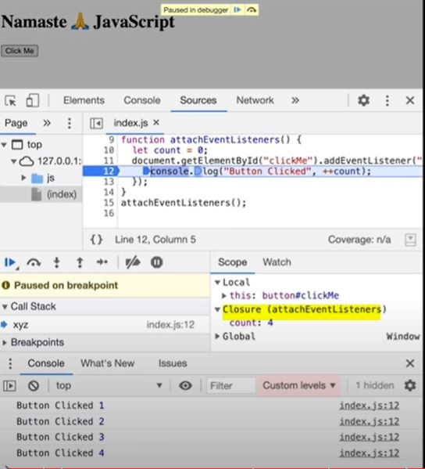

# Episode 15: Asynchronous JavaScript & EVENT LOOP from scratch

Note: Call stack will execute any execution context which enters it. Time, tide and JS waits for none. TLDR; Call stack has no timer.

Browser has JS Engine which has Call Stack which has Global execution context, local execution context etc.

But browser has many other superpowers - Local storage space, Timer, place to enter URL, Bluetooth access, Geolocation access and so on.

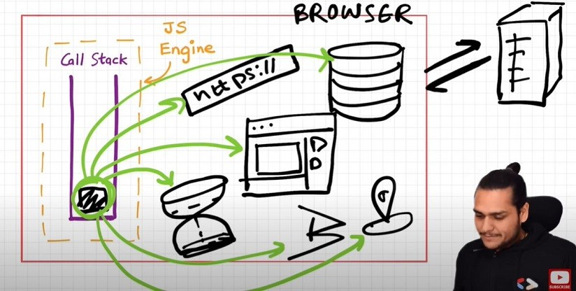Now JS needs some way to connect the call stack with all these superpowers. This is done using Web APIs.

### WebAPIs

None of the below are part of Javascript! These are extra superpowers that browser has. Browser gives access to JS callstack to use these powers.

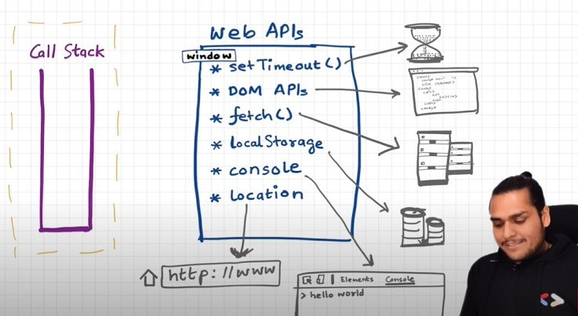

setTimeout(), DOM APIs, fetch(), localstorage, console (yes, even console.log is not JS!!), location and so many more.

setTimeout() : Timer function

DOM APIs : eg.Document.xxxx ; Used to access HTML DOM tree. (Document Object Manipulation) fetch() : Used to make connection with external servers eg. Netflix servers etc.

We get all these inside call stack through global object ie. window

Use window keyword like : window.setTimeout(), window.localstorage, window.console.log() to log something inside console.

As window is global obj, and all the above functions are present in global object, we don't explicitly write window but it is implied.

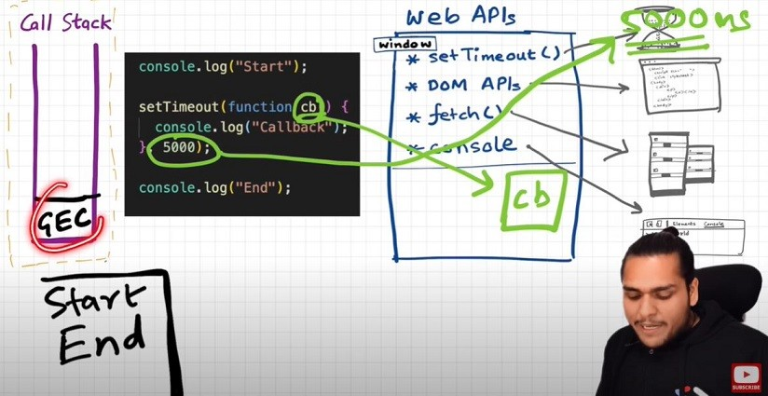Let's undertand the below code image and its explanation:

console.log("start");

setTimeout(function cb() { console.log("timer");

}, 5000);

console.log("end");

// start end timer

First a GEC is created and put inside call stack.

console.log("Start"); // this calls the console web api (through window) which in turn actually modifies values in console.

setTimeout(function cb() { //this calls the setTimeout web api which gives access to timer feature. It stores the callback cb() and starts timer. console.log("Callback");}, 5000);

console.log("End"); // calls console api and logs in console window. After this GEC pops from call stack. While all this is happening, the timer is constantly ticking. After it becomes 0, the callback cb() has to run. Now we need this cb to go into call stack. Only then will it be executed. For this we need **event loop** and **Callback queue**

### Event Loops and Callback Queue

Q: How after 5 secs timer is console?

cb() cannot simply directly go to callstack to be execeuted. It goes through the callback queue when timer expires. Event loop keep checking the callback queue, and see if it has any element to puts it into call stack. It is like a gate keeper.

Once cb() is in callback queue, eventloop pushes it to callstack to run. Console API is used and log printed

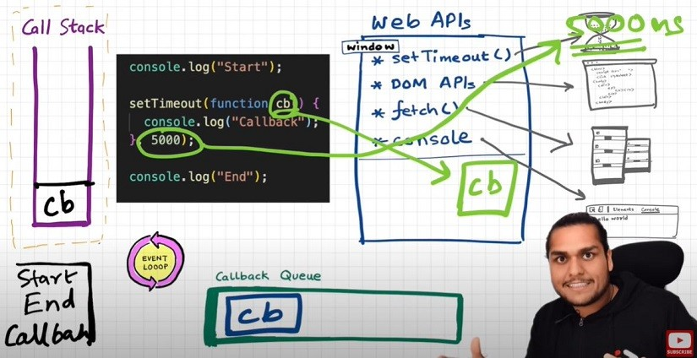

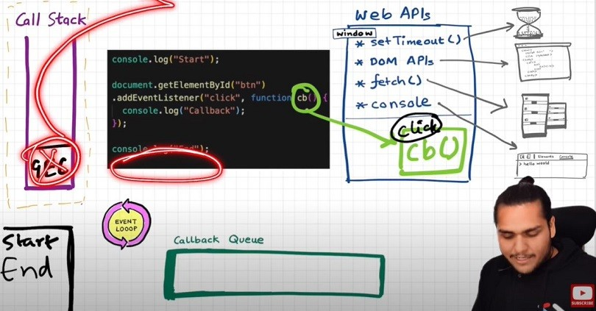Q: Another example to understand Eventloop & Callback Queue. See the below Image and code and try to understand the reason:

Explanation?

console.log("Start");

document.getElementById("btn").addEventListener("click", function cb() {

// cb() registered inside webapi environment and event(click) attached to it. i.e.

REGISTERING CALLBACK AND ATTACHING EVENT TO IT.

console.log("Callback");

});

console.log("End"); // calls console api and logs in console window. After this GEC get removed from call stack.

// In above code, even after console prints "Start" and "End" and pops GEC out, the event Listener stays in webapi env(with hope that user may click it someday) until explicitly removed, or the browser is closed.

Eventloop has just one job to keep checking callback queue and if found something push it to call stack and delete from callback queue.

Q: Need of callback queue?

**Ans**: Suppose user clciks button x6 times. So 6 cb() are put inside callback queue. Event loop sees if call stack is empty/has space and whether callback queue is not empty(6 elements here). Elements of callback queue popped off, put in callstack, executed and then popped off from call stack.

Behavior of fetch (**Micro task Queue?**)

Let's observe the code below and try to understand

console.log("Start"); // this calls the console web api (through window) which in turn actually modifies values in console.

setTimeout(function cbT() { console.log("CB Timeout");

}, 5000);

fetch("https://api.netflix.com").then(function cbF() { console.log("CB Netflix");

}); // take 2 seconds to bring response

// millions lines of code console.log("End");

Code Explanation:

* Same steps for everything before fetch () in above code.
* fetch registers cbF into webapi environment along with existing cbT.
* cbT is waiting for 5000ms to end so that it can be put inside callback queue. cbF is waiting for data to be returned from Netflix servers gonna take 2 seconds.
* After this millions of lines of code is running, by the time millions line of code will execute, 5 seconds has finished and now the timer has expired and response from Netflix server is ready.
* Data back from cbF ready to be executed gets stored into something called a Microtask Queue.
* Also after expiration of timer, cbT is ready to execute in Callback Queue.
* Microtask Queue is exactly same as Callback Queue, but it has higher priority. Functions in Microtask Queue are executed earlier than Callback Queue.
* In console, first Start and End are printed in console. First cbF goes in callstack and "CB Netflix" is printed. cbF popped from callstack. Next cbT is removed from callback

Queue, put in Call Stack, "CB Timeout" is printed, and cbT removed from callstack.

* See below Image for more understanding

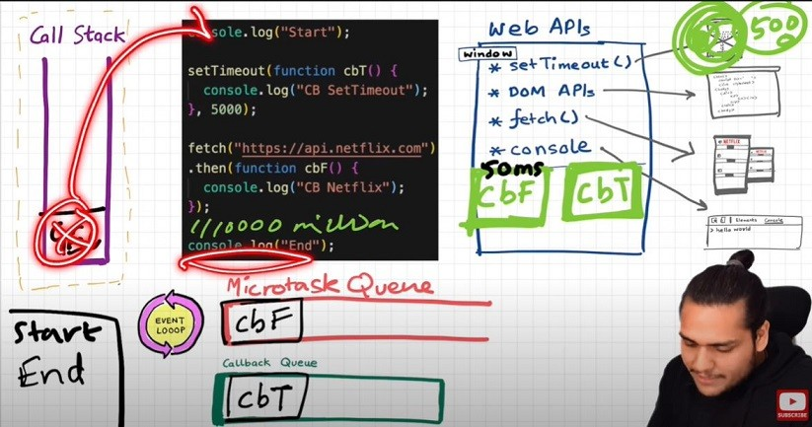

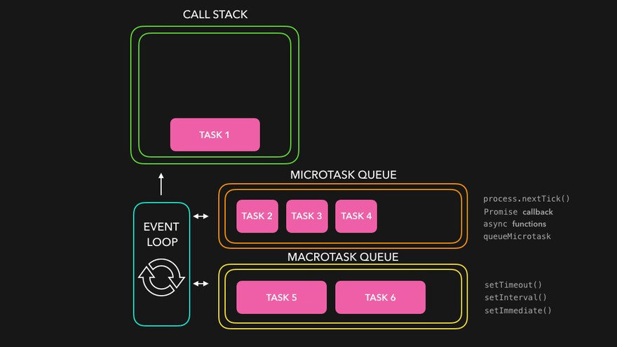Microtask Priority Visualization

#### What enters the Microtask Queue ?

All the callback functions that come through promises go in microtask Queue.

**Mutation Observer** : Keeps on checking whether there is mutation in DOM tree or not, and if there, then it execeutes some callback function.

Callback functions that come through promises and mutation observer go inside **Microtask Queue**. All the rest goes inside **Callback Queue aka. Task Queue**.

If the task in microtask Queue keeps creating new tasks in the queue, element in callback queue never gets chance to be run. This is called **starvation**

### Some Important Questions

1. **When does the event loop actually start ? -** Event loop, as the name suggests, is a single-thread, loop that is

*almost infinite*. It's always running and doing its job.

1. **Are only asynchronous web api callbacks are registered in web api environment? -** YES, the synchronous callback functions like what we pass inside map, filter and reduce aren't registered in the Web API environment. It's just those async callback functions which go through all this.
2. **Does the web API environment stores only the callback function and pushes the same callback to queue/microtask queue? -** Yes, the callback functions are stored, and a reference is scheduled in the queues. Moreover, in the case of event listeners(for example click handlers), the original callbacks stay in the web API environment forever, that's why it's adviced to explicitly remove the listeners when not in use so that the garbage collector does its job.
3. **How does it matter if we delay for setTimeout would be 0ms. Then callback will move to queue without any wait ? -** No, there are trust issues with setTimeout() 😅. The callback function needs to wait until the Call Stack is empty. So the 0 ms callback might have to wait for 100ms also if the stack is busy.

### Observation of Eventloop, Callback Queue & Microtask Queue [**GiF**]

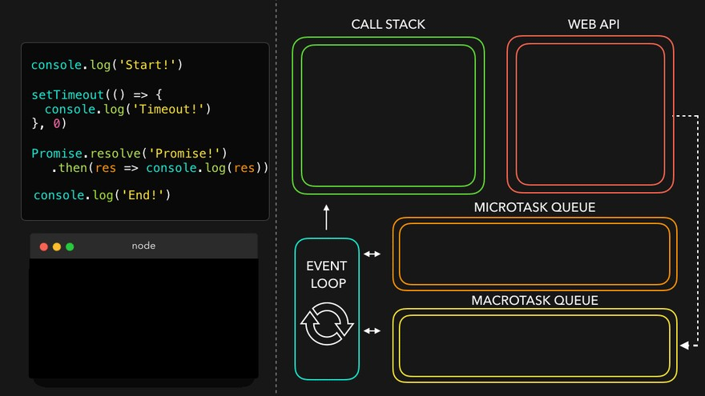

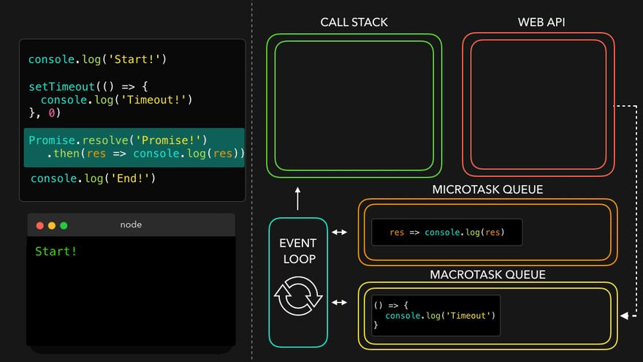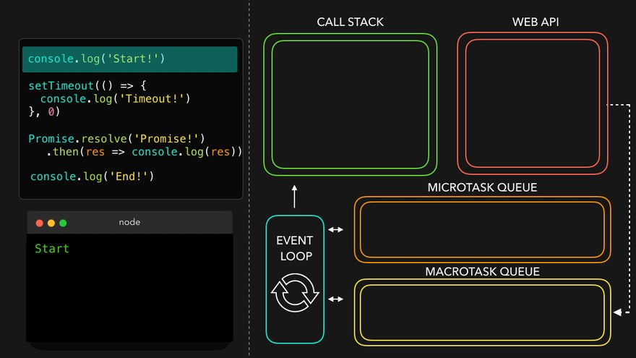

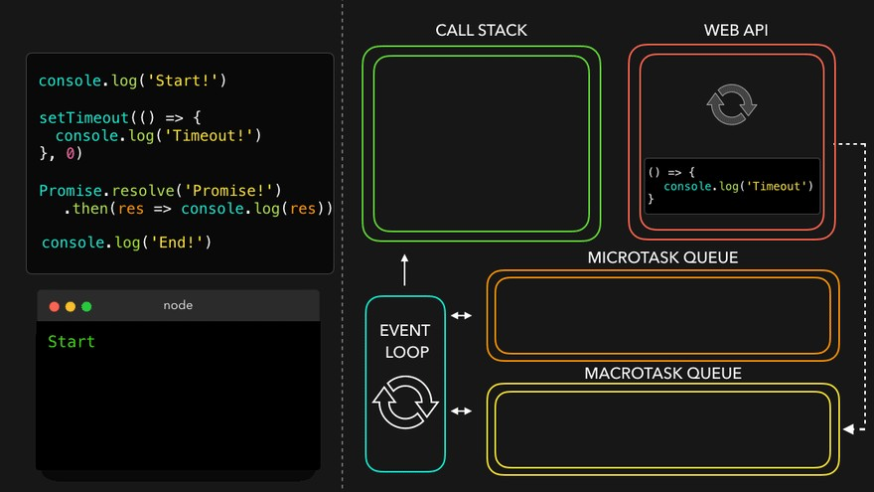

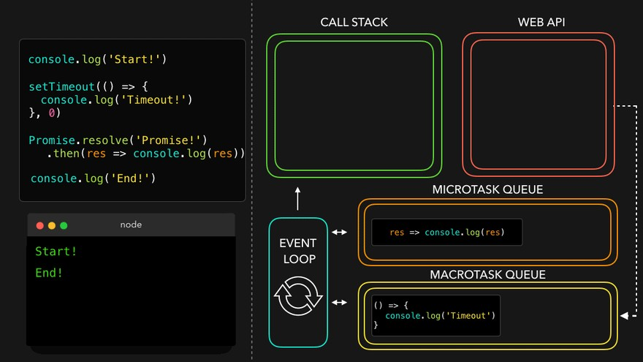

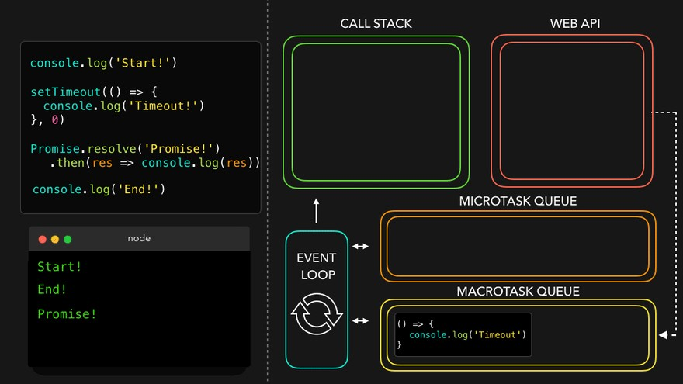

# Episode 16: JS Engine Exposed, Google's V8 Architecture

JS runs literally everywhere from smart watch to robots to browsers because of JavaScript Runtime Environment (JRE).

JRE is like a big container which has everything which are required to run JavaScript code.

JRE consists of a JS Engine (❤ of JRE), set of APIs to connect with outside environment, event loop, Callback queue, Microtask queue etc.

Browser can execute JavaScript code because it has the JavaScript Runtime Environment.

ECMAScript is a governing body of JS. It has set of rules which are followed by all JS engines like Chakra(Edge), Spidermonkey(Firefox)(first JavaScript engine created by JS creator himself), v8(Chrome)

Javascript Engine is not a machine. Its software written in low level languages (eg. C++) that takes in hi-level code in JS and spits out low level machine code.

Code inside Javascript Engine passes through 3 steps : **Parsing**, **Compilation** and **Execution**

* 1. **Parsing** - Code is broken down into tokens. In "let a = 7" -> let, a, =, 7 are all tokens. Also we have a syntax parser that takes code and converts it into an AST (Abstract Syntax Tree) which is a JSON with all key values

like type, start, end, body etc (looks like package.json but for a line of code in JS. Kinda unimportant) (Check out astexplorer.net -> converts line of code into AST).

* 1. **Compilation** - JS has something called Just-in-time(JIT) Compilation - uses both interpreter & compiler. Also compilation and execution both go hand in hand. The AST from previous step goes to interpreter which converts hi-level code to byte code and moves to execution. While interpreting, compiler also works hand in hand to compile and form optimized code during runtime. **Does JavaScript really Compile?** The answer is a loud **YES**. More info at: [Link 1](https://github.com/getify/You-Dont-Know-JS/blob/2nd-ed/get-started/ch1.md#whats-in-an-interpretation), [Link 2](https://web.stanford.edu/class/cs98si/slides/overview.html), [Link 3](https://blog.greenroots.info/javascript-interpreted-or-compiled-the-debate-is-over-ckb092cv302mtl6s17t14hq1j). JS used to be only interpreter in old times, but now has both to compile and interpreter code and this make JS a JIT compiled language, it’s like best of both world.
  2. **Execution** - Needs 2 components ie. Memory heap (place where all memory is stored) and Call Stack (same call stack from prev episodes). There is also a garbage collector. It uses an algo called **Mark and Sweep**.

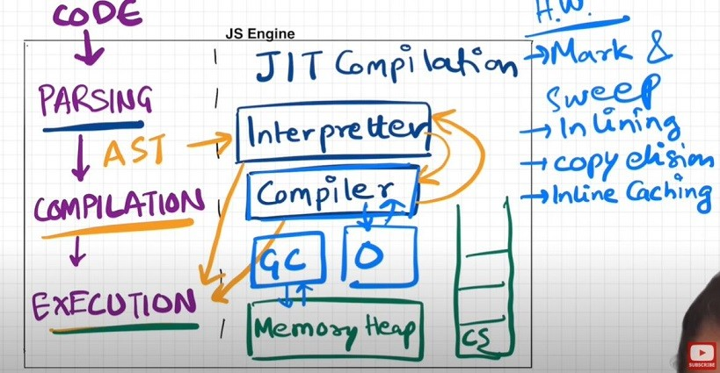

Companies use different JS engines and each try to make theirs the best.

v8 of Google has Interpreter called Ignition, a compiler called Turbo Fan and garbage collector called Orinoco

v8 architecture:

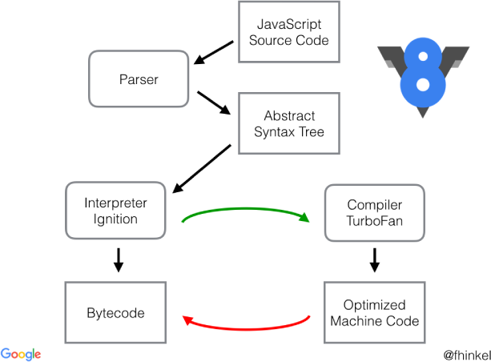

# Episode 17: Trust issues with setTimeout()

setTimeout with timer of 5 secs sometimes does not exactly guarantees that the callback function will execute exactly after 5s.

Let's observe the below code and it's explanation

console.log("Start");

setTimeout(function cb() { console.log("Callback");

}, 5000);

console.log("End");

// Millions of lines of code to execute

// o/p: Over here setTimeout exactly doesn't guarantee that the callback function will be called exactly after 5s. Maybe 6,7 or even 10! It all depends on callstack. Why?

Reason?

First GEC is created and pushed in callstack.

Start is printed in console

When setTimeout is seen, callback function is registered into webapi's env. And timer is attached to it and started. callback waits for its turn to be execeuted once timer expires. But JS waits for none. Goes to next line. End is printed in console.

After "End", we have 1 million lines of code that takes 10 sec(say) to finish execution. So GEC won't pop out of stack. It runs all the code for 10 sec.

But in the background, the timer runs for 5s. While callstack runs the 1M line of code, this timer has already expired and callback fun has been pushed to Callback queue and waiting to pushed to callstack to get executed.

Event loop keeps checking if callstack is empty or not. But here GEC is still in stack so cb can't be popped from callback Queue and pushed to CallStack. **Though setTimeout is only for 5s, it waits for 10s until callstack is empty before it can execute** (When GEC popped after 10sec, callstack() is pushed into call stack and immediately executed (Whatever is pushed to callstack is executed instantly).

This is called as the [**Concurrency model**](https://developer.mozilla.org/en-US/docs/Web/JavaScript/EventLoop) of JS. This is the logic behind setTimeout's trust issues.

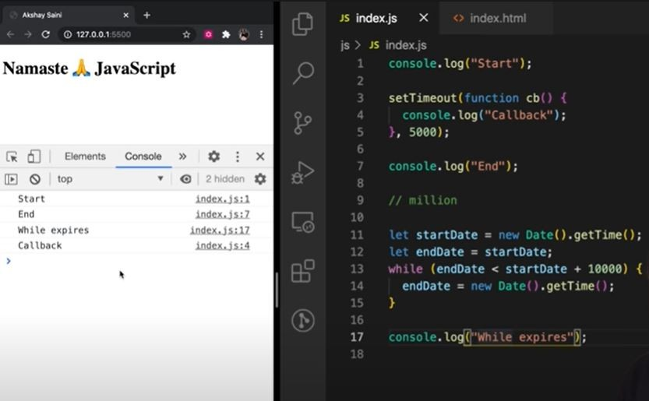The First rule of JavaScript: Do not **block the main thread** (as JS is a single threaded(only 1 callstack) language). In below example, we are blocking the main thread. Observe Questiona and Output.

setTimeout guarantees that it will take at least the given timer to execute the code.

JS is a synchronous single threaded language. With just 1 thread it runs all pieces of code. It becomes kind of an interpreter language, and runs code very fast inside browser (no need to wait for code to be compiled) (JIT - Just in time compilation). And there are still ways to do async operations as well.

What if **timeout = 0sec**?

console.log("Start");

setTimeout(function cb() { console.log("Callback");

}, 0);

console.log("End");

// Even though timer = 0s, the cb() has to go through the queue. Registers calback in webapi's env , moves to callback queue, and execute once callstack is empty.

// O/p - Start End Callback

// This method of putting timer = 0, can be used to defer a less imp function by a little so the more important function(here printing "End") can take place

# Episode 18: Higher-Order Functions ft. Functional Programming

### Q: What is Higher Order Function?

**Ans**: A Higher-order functions are regular functions that take other functions as arguments or return functions as their results. Eg:

function x() {

console.log("Hi)";

};

function y(x) { x();

};

y(); // Hi

// y is a higher order function

// x is a callback function

Let's try to understand how we should approach solution in interview. I have an array of radius and I have to calculate area using these radius and store in an array.

First Approach:

const radius = [1, 2, 3, 4];

const calculateArea = function (radius) { const output = [];

for (let i = 0; i < radius.length; i++) {

output.push(Math.PI * radius[i] * radius[i]);

}

return output;

};

console.log(calculateArea(radius));

The above solution works perfectly fine but what if we have now requirement to calculate array of circumference. Code now be like

const radius = [1, 2, 3, 4];

const calculateCircumference = function (radius) { const output = [];

for (let i = 0; i < radius.length; i++) { output.push(2 * Math.PI * radius[i]);}

return output;

};

console.log(calculateCircumference(radius));

But over here we are violating some principle like DRY Principle, now lets observe the better approach.

const radiusArr = [1, 2, 3, 4];

// logic to calculate area

const area = function (radius) {

return Math.PI * radius * radius;

}

// logic to calculate circumference

const circumference = function (radius) { return 2 * Math.PI * radius;

}

const calculate = function(radiusArr, operation) { const output = [];

for (let i = 0; i < radiusArr.length; i++) { output.push(operation(radiusArr[i]));

}

return output;

}

console.log(calculate(radiusArr, area));

console.log(calculate(radiusArr, circumference));

// Over here calculate is HOF

// Over here we have extracted logic into separate functions. This is the beauty of functional programming.

Polyfill of map

// Over here calculate is nothing but polyfill of map function

// console.log(radiusArr.map(area)) == console.log(calculate(radiusArr, area));

***************************************************

Lets convert above calculate function as map function and try to use. So,

Array.prototype.calculate = function(operation) { const output = [];

for (let i = 0; i < this.length; i++) { output.push(operation(this[i]));

}

return output;

}

console.log(radiusArr.calculate(area))

# Episode 19: map, filter & reduce

map, filter & reducer are Higher Order Functions.

## Map function

It is basically used to transform a array. The map() method creates a new array with the results of calling a function for every array element.

const output = arr.map(*function*) // this *function* tells map that what transformation I want on each element of array

const arr = [5, 1, 3, 2, 6];

// Task 1: Double the array element: [10, 2, 6, 4, 12] function double(x) {

return x * 2;

}

const doubleArr = arr.map(double); // Internally map will run double function for each element of array and create a new array and returns it.

console.log(doubleArr); // [10, 2, 6, 4, 12]

// Task 2: Triple the array element const arr = [5, 1, 3, 2, 6];

// Transformation logic function triple(x) {

return x * 3;

}

const tripleArr = arr.map(triple);

console.log(tripleArr); // [15, 3, 9, 6, 18]

// Task 3: Convert array elements to binary const arr = [5, 1, 3, 2, 6];

// Transformation logic:

function binary(x) {

return x.toString(2);

}

const binaryArr = arr.map(binary);

// The above code can be rewritten as :

const binaryArr = arr.map(function binary(x) { return x.toString(2);

}

// OR -> Arrow function

const binaryArr = arr.map((x) => x.toString(2));

So basically map function is mapping each and every value and transforming it based on given condition.

## Filter function

Filter function is basically used to filter the value inside an array. The arr.filter() method is used to create a new array from a given array consisting of only those elements from the given array which satisfy a condition set by the argument method.

const array = [5, 1, 3, 2, 6];

// filter odd values function isOdd(x) {

return x % 2;

}

const oddArr = array.filter(isOdd); // [5,1,3]

// Other way of writing the above:

const oddArr = arr.filter((x) => x % 2);

Filter function creates an array and store only those values which evaluates to true.

## Reduce function

It is a function which take all the values of array and gives a single output of it. It reduces the array to give a single output.

const array = [5, 1, 3, 2, 6];

// Calculate sum of elements of array - Non functional programming way

function findSum(arr) { let sum = 0;

for (let i = 0; i < arr.length; i++) { sum = sum + arr[i];

}

return sum;

}

console.log(findSum(array)); // 17

// reduce function way

const sumOfElem = arr.reduce(function (accumulator, current) {

// current represent the value of array

// accumulator is used the result from element of array.

// In comparison to previous code snippet, *sum* variable is *accumulator* and *arr[i]* is *current*

accumulator = accumulator + current; return accumulator;

}, 0); //In above example sum was initialized with 0, so over here accumulator also needs to be initialized, so the second argument to reduce function represent the initialization value.

console.log(sumOfElem); // 17

// find max inside array: Non functional programming way: const array = [5, 1, 3, 2, 6];

function findMax(arr) { let max = 0;

for(let i = 0; i < arr.length; i++ { if (arr[i] > max) {

max = arr[i]

}

}

return max;

}

console.log(findMax(array)); // 6

// using reduce

const output = arr.reduce((acc, current) => { if (current > acc ) {

acc = current;

}

return acc;

}, 0);

console.log(output); // 6

// acc is just a label which represent the accumulated value till now,

// so we can also label it as max in this case const output = arr.reduce((max, current) => {

if (current > max) {

max= current;

}

return max;

}, 0);

console.log(output); // 6

## Tricky MAP

const users = [

{ firstName: "Alok", lastName: "Raj", age: 23 },

{ firstName: "Ashish", lastName: "Kumar", age: 29 },

{ firstName: "Ankit", lastName: "Roy", age: 29 },

{ firstName: "Pranav", lastName: "Mukherjee", age: 50 },

];

// Get array of full name : ["Alok Raj", "Ashish Kumar", ...]

const fullNameArr = users.map((user) => user.firstName + " " + user.lastName); console.log(fullNameArr); // ["Alok Raj", "Ashish Kumar", ...]

// Get the count/report of how many unique people with unique age are there

// like: {29 : 2, 75 : 1, 50 : 1}

// We should use reduce, why? we want to deduce some information from the array. Basically we want to get a single object as output

const report = users.reduce((acc, curr) => { if(acc[curr.age]) {

acc[curr.age] = ++ acc[curr.age] ;

} else {

acc[curr.age] = 1;

}

return acc; //to every time return update object

}, {})

console.log(report) // {29 : 2, 75 : 1, 50 : 1}

Function Chaining

// First name of all people whose age is less than 30 const users = [

{ firstName: "Alok", lastName: "Raj", age: 23 },

{ firstName: "Ashish", lastName: "Kumar", age: 29 },

{ firstName: "Ankit", lastName: "Roy", age: 29 },

{ firstName: "Pranav", lastName: "Mukherjee", age: 50 },

];

// function chaining const output = users

.filter((user) => user.age < 30)

.map((user) => user.firstName);

console.log(output); // ["Alok", "Ashish", "Ankit"]

// Homework challenge: Implement the same logic using reduce const output = users.reduce((acc, curr) => {

if (curr.age < 30) {

acc.push(curr.firstName);

}

return acc;

}, []);

console.log(output); // ["Alok", "Ashish", "Ankit"]

# Episode 20: Callback

There are 2 Parts of Callback:

1. Good Part of callback - Callback are super important while writing asynchronous code in JS
2. Bad Part of Callback - Using callback we can face issue: Callback Hell

Inversion of control

Understanding of Bad part of callback is super important to learn Promise in next lecture.

💡 JavaScript is synchronous, single threaded language. It can Just do one thing at a time, it has just one call-stack and it can execute one thing at a time. Whatever code we give to Javascript will be quickly executed by Javascript engine, it does not wait.

console.log("Namaste");

console.log("JavaScript"); console.log("Season 2");

// Namaste

// JavaScript

// Season 2

// 💡 It is quickly printing because `Time, tide & Javascript waits for none.`

*But what if we have to delay execution of any line, we could utilize callback, How?*

console.log("Namaste"); setTimeout(function () {

console.log("JavaScript");

}, 5000);

console.log("Season 2");

// Namaste

// Season 2

// JavaScript

// 💡 Here we are delaying the execution using callback approach of setTimeout.

### 🛒 e-Commerce web app situation

Assume a scenario of e-Commerce web, where one user is placing order, he has added items like, shoes, pants and kurta in cart and now he is placing order. So in backend the situation could look something like this.

const cart = ["shoes", "pants", "kurta"];

// Two steps to place a order

// 1. Create a Order

// 2. Proceed to Payment

// It could look something like this: api.createOrder();

api.proceedToPayment();

Assumption, once order is created then only we can proceed to payment, so there is a dependency. So How to manage this dependency. Callback can come as rescue, How?

api.createOrder(cart, function () { api.proceedToPayment();

});

// 💡 Over here `createOrder` api is first creating a order then it is responsible to call

`api.proceedToPayment()` as part of callback approach.

To make it a bit complicated, what if after payment is done, you have to show Order summary by calling

api.showOrderSummary() and now it has dependency on api.proceedToPayment() Now my code should look something like this:

api.createOrder(cart, function () { api.proceedToPayment(function () {

api.showOrderSummary();

});

});

Now what if we have to update the wallet, now this will have a dependency over showOrderSummary

api.createOrder(cart, function () { api.proceedToPayment(function () {

api.showOrderSummary(function () { api.updateWallet();

});

});

});

// 💡 Callback Hell

When we have a large codebase and multiple apis and have dependency on each other, then we fall into callback hell. These codes are tough to maintain. These callback hell structure is also known as **Pyramid of Doom**.

Till this point we are comfortable with concept of callback hell but now lets discuss about Inversion of Control. It is very important to understand in order to get comfortable around the concept of promise.

💡 Inversion of control is like that you lose the control of code when we are using callback.

Let's understand with the help of example code and comments:

api.createOrder(cart, function () { api.proceedToPayment();

});

// 💡 So over here, we are creating a order and then we are blindly trusting `createOrder` to call `proceedToPayment`.

// 💡 It is risky, as `proceedToPayment` is important part of code and we are blindly trusting `createOrder` to call it and handle it.

// 💡 When we pass a function as a callback, basically we are dependant on our parent

function that it is his responsibility to run that function. This is called `inversion of control` because we are dependant on that function. What if parent function stopped

working, what if it was developed by another programmer or callback runs two times or never run at all.

// 💡 In next session, we will see how we can fix such problems.

💡 Async programming in JavaScript exists because callback exits.

more at <http://callbackhell.com/>

# Episode 21: Promises

Promises are used to handle async operations in JavaScript.

We will discuss with code example that how things used to work before Promises and then how it works after Promises

Suppose, taking an example of E-Commerce

const cart = ["shoes", "pants", "kurta"];

// Below two functions are asynchronous and dependent on each other const orderId = createOrder(cart);

proceedToPayment(orderId);

// with Callback (Before Promise)

// Below here, it is the responsibility of createOrder function to first create the order then call the callback function

createOrder(cart, function () { proceedToPayment(orderId);

});

// Above there is the issue of `Inversion of Control`

Q: How to fix the above issue?

*A: Using Promise.*

Now, we will make createOrder function return a promise and we will capture that promise into a variable

Promise is nothing but we can assume it to be empty object with some data value in it, and this data value will hold whatever this createOrder function will return.

Since createOrder function is an async function and we don't know how much time will it take to finish execution.

So the moment createOrder will get executed, it will return you a undefined value. Let's say after 5 secs execution finished so now orderId is ready so, it will fill the undefined value with the orderId.

In short, When createOrder get executed, it immediately returns a promise object with undefined value. then javascript will continue to execute with other lines of code. After sometime when createOrder has finished execution and orderId is ready then that will automatically be assigned to our returned promise which was earlier undefined.

Q: Question is how we will get to know response is ready?

*A: So, we will attach a callback function to the promise object using then to get triggered automatically when result*

*is ready.*

const cart = ["shoes", "pants", "kurta"]; const promiseRef = createOrder(cart);

// this promiseRef has access to `then`

// {data: undefined}

// Initially it will be undefined so below code won't trigger

// After some time, when execution has finished and promiseRef has the data then automatically the below line will get triggered.

promiseRef.then(function () { proceedToPayment(orderId);

});

Q: How it is better than callback approach?

In Earlier solution we used to pass the function and then used to trust the function to execute the callback. But with promise, we are attaching a callback function to a promiseObject.

There is difference between these words, passing a function and attaching a function.

Promise guarantee, it will callback the attached function once it has the fulfilled data. And it will call it only once. Just once.

Earlier we talked about promise are object with empty data but that's not entirely true, Promise are much more than that. Now let's understand and see a real promise object.

fetch is a web-api which is utilized to make api call and it returns a promise.

We will be calling public github api to fetch data https://api.github.com/users/alok722

// We will be calling public github api to fetch data const URL = "https://api.github.com/users/alok722";

const user = fetch(URL);

// User above will be a promise.

console.log(user); // Promise {<Pending>}

/** OBSERVATIONS:

* If we will deep dive and see, this `promise` object has 3 things
* `prototype`, `promiseState` & `promiseResult`
* & this `promiseResult` is the same data which we talked earlier as data
* & initially `promiseResult` is `undefined`

*

* `promiseResult` will store data returned from API call
* `promiseState` will tell in which state the promise is currently, initially it will be in `pending` state and later it will become `fulfilled`

*/

/**

* When above line is executed, `fetch` makes API call and return a `promise` instantly which is in `Pending` state and Javascript doesn't wait to get it `fulfilled`
* And in next line it console out the `pending promise`.
* NOTE: chrome browser has some in-consistency, the moment console happens it shows in

pending state but if you will expand that it will show fulfilled because chrome updated the log when promise get fulfilled.

* Once fulfilled data is there in promiseResult and it is inside body in ReadableStream format and there is a way to extract data.

*/

Now we can attach callback to above response? Using .then

const URL = "https://api.github.com/users/alok722"; const user = fetch(URL);

user.then(function (data) { console.log(data);

});

// And this is how Promise is used.

// It guarantees that it could be resolved only once, either it could be `success` or

`failure`

/**

A Promise is in one of these states:

pending: initial state, neither fulfilled nor rejected.

fulfilled: meaning that the operation was completed successfully. rejected: meaning that the operation failed.

*/

💡Promise Object are immutable.

-> Once promise is fulfilled and we have data we can pass here and there and we don't have to worry that someone can mutate that data. So over above we can't directly mutate user promise object, we will have to use .then

### Interview Guide

💡What is Promise?

-> Promise object is a placeholder for certain period of time until we receive value from asynchronous operation.

-> A container for a future value.

#### -> A Promise is an object representing the eventual completion or failure of an asynchronous operation.

We are now done solving one issue of callback i.e. Inversion of Control But there is one more issue, callback hell...

// Callback Hell Example

createOrder(cart, function (orderId) {

proceedToPayment(orderId, function (paymentInf) { showOrderSummary(paymentInf, function (balance) {

updateWalletBalance(balance);

});

});

});

// And now above code is expanding horizontally and this is called pyramid of doom.

// Callback hell is ugly and hard to maintain.

// 💡 Promise fixes this issue too using `Promise Chaining`

// Example Below is a Promise Chaining createOrder(cart)

.then(function (orderId) {

proceedToPayment(orderId);

})

.then(function (paymentInf) {

showOrderSummary(paymentInf);

})

.then(function (balance) {

updateWalletBalance(balance);

});

// ⚠ Common PitFall

// We forget to return promise in Promise Chaining

// The idea is promise/data returned from one .then become data for next .then

// So,

createOrder(cart)

.then(function (orderId) {

return proceedToPayment(orderId);

})

.then(function (paymentInf) {

return showOrderSummary(paymentInf);

})

.then(function (balance) {

return updateWalletBalance(balance);

});

// To improve readability you can use arrow function instead of regular function

# Episode 22: Creating a Promise, Chaining & Error Handling

const cart = ["shoes", "pants", "kurta"];

// Consumer part of promise

const promise = createOrder(cart); // orderId

// Our expectation is above function is going to return me a promise.

promise.then(function (orderId) { proceedToPayment(orderId);

});

// Above snippet we have observed in our previous lecture itself.

// Now we will see, how createOrder is implemented so that it is returning a promise

// In short we will see, "How we can create Promise" and then return it.

// Producer part of Promise function createOrder(cart) {

// JS provides a Promise constructor through which we can create promise

// It accepts a callback function with two parameter `resolve` & `reject` const promise = new Promise(function (resolve, reject) {

// What is this `resolve` and `reject`?

// These are function which are passed by javascript to us in order to handle success

and failure of function call.

// Now we will write logic to `createOrder`

/** Mock logic steps

* + 1. validateCart
  + 2. Insert in DB and get an orderId

*/

// We are assuming in real world scenario, validateCart would be defined if (!validateCart(cart)) {

// If cart not valid, reject the promise

const err = new Error("Cart is not Valid"); reject(err);

}

const orderId = "12345"; // We got this id by calling to db (Assumption) if (orderId) {

// Success scenario resolve(orderId);

}

});

return promise;

}

Over above, if your validateCart is returning true, so the above promise will be resolved (success),

const cart = ["shoes", "pants", "kurta"];

const promise = createOrder(cart); // orderId

// ❓ What will be printed in below line?

// It prints Promise {<pending>}, but why?

// Because above createOrder is going to take sometime to get resolved, so pending state. But once the promise is resolved, `.then` would be executed for callback.

console.log(promise);

promise.then(function (orderId) { proceedToPayment(orderId);

});

function createOrder(cart) {

const promise = new Promise(function (resolve, reject) { if (!validateCart(cart)) {

const err = new Error("Cart is not Valid"); reject(err);

}

const orderId = "12345"; if (orderId) {

resolve(orderId);

}

});

return promise;

}

Now let's see if there was some error and we are rejecting the promise, how we could catch that?

-> Using .catch

const cart = ["shoes", "pants", "kurta"];

const promise = createOrder(cart); // orderId

// Here we are consuming Promise and will try to catch promise error promise

.then(function (orderId) {

// ✅ success aka resolved promise handling proceedToPayment(orderId);

})

.catch(function (err) {

// ⚠ failure aka reject handling console.log(err);

});

// Here we are creating Promise function createOrder(cart) {

const promise = new Promise(function (resolve, reject) {

// Assume below `validateCart` return false then the promise will be rejected

// And then our browser is going to throw the error. if (!validateCart(cart)) {

const err = new Error("Cart is not Valid"); reject(err);

}

const orderId = "12345"; if (orderId) {

resolve(orderId);

}

});

return promise;

}

Now, Let's understand the concept of Promise Chaining

-> for this we will assume after createOrder we have to invoke proceedToPayment

-> In promise chaining, whatever is returned from first .then become data for next .then and so on...

-> At any point of promise chaining, if promise is rejected, the execution will fall back to .catch and others promise won't run.

const cart = ["shoes", "pants", "kurta"]; createOrder(cart)

.then(function (orderId) {

// ✅ success aka resolved promise handling

// 💡 we have return data or promise so that we can keep chaining the promises, here we are returning data

console.log(orderId); return orderId;

})

.then(function (orderId) {

// Promise chaining

// 💡 we will make sure that `proceedToPayment` returns a promise too return proceedToPayment(orderId);

})

.then(function (paymentInfo) {

// from above, `proceedToPayment` is returning a promise so we can consume using

`.then`

console.log(paymentInfo);

})

.catch(function (err) {

// ⚠ failure aka reject handling console.log(err);

});

// Here we are creating Promise function createOrder(cart) {

const promise = new Promise(function (resolve, reject) {

// Assume below `validateCart` return false then the promise will be rejected

// And then our browser is going to throw the error. if (!validateCart(cart)) {

const err = new Error("Cart is not Valid"); reject(err);

}

const orderId = "12345"; if (orderId) {

resolve(orderId);

}

});

return promise;

}

function proceedToPayment(cart) {

return new Promise(function (resolve, reject) {

// For time being, we are simply `resolving` promise resolve("Payment Successful");

});

}

Q: What if we want to continue execution even if any of my promise is failing, how to achieve this?

-> By placing the .catch block at some level after which we are not concerned with failure.

-> There could be multiple .catch too.

Eg:

createOrder(cart)

.then(function (orderId) {

// ✅ success aka resolved promise handling

// 💡 we have return data or promise so that we can keep chaining the promises, here we are returning data

console.log(orderId); return orderId;

})

.catch(function (err) {

// ⚠ Whatever fails below it, catch wont care

// this block is responsible for code block above it. console.log(err);

});

.then(function (orderId) {

// Promise chaining

// 💡 we will make sure that `proceedToPayment` returns a promise too return proceedToPayment(orderId);

})

.then(function (paymentInfo) {

// from above, `proceedToPayment` is returning a promise so we can consume using

`.then`

console.log(paymentInfo);

})

# Episode 23: async await

Topics Covered

What is async? What is await?

How async await works behind the scenes? Example of using async/await

Error Handling Interviews

Async await vs Promise.then/.catch

Q: What is async?

A: Async is a keyword that is used before a function to create a async function.

Q: What is async function and how it is different from normal function?

// 💡 async function always returns a promise, even if I return a simple string from below function, async keyword will wrap it under Promise and then return.

async function getData() {

return "Namaste JavaScript";

}

const dataPromise = getData();

console.log(dataPromise); // Promise {<fulfilled>: 'Namaste JavaScript'}

//❓How to extract data from above promise? One way is using promise .then dataPromise.then(res => console.log(res)); // Namaste JavaScript

Another example where async function is returning a Promise

const p = new Promise((resolve, reject) => { resolve('Promise resolved value!!');

})

async function getData() { return p;

}

// In above case, since we are already returning a promise async function would simply return that instead of wrapping with a new Promise.

const dataPromise = getData();

console.log(dataPromise); // Promise {<fulfilled>: 'Promise resolved value!!'} dataPromise.then(res => console.log(res)); // Promise resolved value!!

Q: How we can use await along with async function? A: async and await combo is used to handle promises.

But Question is how we used to handle promises earlier and why we even need async/await?

const p = new Promise((resolve, reject) => { resolve('Promise resolved value!!');

})

function getData() {

p.then(res => console.log(res));

}

getData(); // Promise resolved value!!

//📌 Till now we have been using Promise.then/.catch to handle promise.

// Now let's see how async await can help us and how it is different

// The rule is we have to use keyword await in front of promise. async function handlePromise() {

const val = await p; console.log(val);

}

handlePromise(); // Promise resolved value!!

📌 await is a keyword that can only be used inside a async function.

await function() {} // Syntax error: await is only valid under async function.

Q: What makes async-await special?

A: Let's understand with one example where we will compare async-await way of resolving promise with older .then/.catch fashion. For that we will modify our promise p.

const p = new Promise((resolve, reject) => { setTimeout(() => {

resolve('Promise resolved value!!');

}, 3000);

})

// Let's now compare with some modification:

// 📌 Promise.then/.catch way function getData() {

// JS engine will not wait for promise to be resolved p.then(res => console.log(res));

console.log('Hello There!');

}

getData(); // First `Hello There!` would be printed and then after 3 secs 'Promise resolved value!!' will be printed.

// Above happened as Javascript wait for none, so it will register this promise and take this callback function and register separately then js will move on and execute the

following console and later once promise is resolved, following console will be printed.

//❓ Problem: Normally one used to get confused that JS will wait for promise to be resolved before executing following lines.

// 📌 async-wait way:

async function handlePromise() {

// JS Engine will waiting for promise to resolve. const val = await p;

console.log('Hello There!'); console.log(val);

}

handlePromise(); // This time `Hello There!` won't be printed immediately instead after 3 secs `Hello There!` will be printed followed by 'Promise resolved value!!'

// 💡 So basically code was waiting at `await` line to get the promise resolve before

moving on to next line.

// Above is the major difference between Promise.then/.catch vs async-await

//🤓 Let's brainstorm more around async-await async function handlePromise() {

console.log('Hi');

const val = await p;

console.log('Hello There!'); console.log(val);

const val2 = await p;

console.log('Hello There! 2');

console.log(val2);

}

handlePromise();

// In above code example, will our program wait for 2 time or will it execute parallely.

//📌 `Hi` printed instantly -> now code will wait for 3 secs -> After 3 secs both promises will be resolved so ('Hello There!' 'Promise resolved value!!' 'Hello There! 2' 'Promise

resolved value!!') will get printed immediately.

// Let's create one promise and then resolve two different promise. const p2 = new Promise((resolve, reject) => {

setTimeout(() => {

resolve('Promise resolved value by p2!!');

}, 2000);

})

async function handlePromise() { console.log('Hi');

const val = await p;

console.log('Hello There!'); console.log(val);

const val2 = await p2;

console.log('Hello There! 2'); console.log(val2);

}

handlePromise();

// 📌 `Hi` printed instantly -> now code will wait for 3 secs -> After 3 secs both promises will be resolved so ('Hello There!' 'Promise resolved value!!' 'Hello There! 2' 'Promise

resolved value by p2!!') will get printed immediately. So even though `p2` was resolved after 2 secs it had to wait for `p` to get resolved

// Now let's reverse the order execution of promise and observe response. async function handlePromise() {

console.log('Hi');

const val = await p2;

console.log('Hello There!'); console.log(val);

const val2 = await p;

console.log('Hello There! 2'); console.log(val2);

}

handlePromise();

// 📌 `Hi` printed instantly -> now code will wait for 2 secs -> After 2 secs ('Hello There!' 'Promise resolved value by p2!!') will get printed and in the subsequent second

i.e. after 3 secs ('Hello There! 2' 'Promise resolved value!!') will get printed

Q: Question is Is program actually waiting or what is happening behind the scene?

A: As we know, Time, Tide and JS wait for none. And it's true. Over here it appears that JS engine is waiting but JS engine is not waiting over here. It has not occupied the call stack if that would have been the case our page may have got frozen. So JS engine is not waiting. So if it is not waiting then what it is doing behind the scene? Let's understand with below code snippet.

const p1 = new Promise((resolve, reject) => { setTimeout(() => {

resolve('Promise resolved value by p1!!');

}, 5000);

})

const p2 = new Promise((resolve, reject) => { setTimeout(() => {

resolve('Promise resolved value by p2!!');

}, 10000);

})

async function handlePromise() { console.log('Hi');

debugger;

const val = await p;

console.log('Hello There!'); debugger;

console.log(val);

const val2 = await p2;

console.log('Hello There! 2'); debugger;

console.log(val2);

}

handlePromise();

// When this function is executed, it will go line by line as JS is synchronous single

threaded language. Lets observe what is happening under call-stack. Above you can see we have set the break-points.

// call stack flow -> handlePromise() is pushed -> It will log `Hi` to console -> Next it sees we have await where promise is suppose to be resolved -> So will it wait for promise to resolve and block call stack? No -> thus handlePromise() execution get suspended and

moved out of call stack -> So when JS sees await keyword it suspend the execution of function till promise is resolved -> So `p` will get resolved after 5 secs so

handlePromise() will be pushed to call-stack again after 5 secs. -> But this time it will start executing from where it had left. -> Now it will log 'Hello There!' and 'Promise

resolved value!!' -> then it will check whether `p2` is resolved or not -> It will find

since `p2` will take 10 secs to resolve so the same above process will repeat -> execution will be suspended until promise is resolved.

// 📌 Thus JS is not waiting, call stack is not getting blocked.

// Moreover in above scenario what if p1 would be taking 10 secs and p2 5 secs -> even

though p2 got resolved earlier but JS is synchronous single threaded language so it will first wait for p1 to be resolved and then will immediately execute all.

### Real World example of async/await

async function handlePromise() {

// fetch() => Response Object which as body as Readable stream => Response.json() is also a promise which when resolved => value

const data = await fetch('https://api.github.com/users/alok722'); const res = await data.json();

console.log(res);

};

handlePromise()

Error Handling

While we were using normal Promise we were using .catch to handle error, now in async-await we would be using try- catch block to handle error.

async function handlePromise() { try {

const data = await fetch('https://api.github.com/users/alok722'); const res = await data.json();

console.log(res);

} catch (err) {

console.log(err)

}

};

handlePromise()

// In above whenever any error will occur the execution will move to catch block. One could try above with bad url which will result in error.

// Other way of handling error:

handlePromise().catch(err => console.log(err)); // this will work as handlePromise will return error promise in case of failure.

### Async await vs Promise.then/.catch

What one should use? async-await is just a syntactic sugar around promise. Behind the scene async-await is just promise. So both are same, it's just async-await is new way of writing code. async-await solves few of the short- coming of Promise like Promise Chaining. async-await also increases the readability. So sort of it is always advisable to use async-await.

# Episode 24: Promise APIs (all, allSettled, race, any) + Interview Questions 🔥

4 Promise APIs which are majorly used: Promise.all()

Promise.allSettled() Promise.race() Promise.any()

💡 One simply doesn't use async/await without knowing promises!

### Promise.all()

A promise is a placeholder for a value that's going to be available sometime later. The promise helps handle asynchronous operations. JavaScript provides a helper function Promise.all(promisesArrayOrIterable) to handle multiple promises at once, in parallel, and get the results in a single aggregate array.

Q: In what situation one could use above api?

A: Suppose, you have to make parallel API call and get the result, how one can do? This is where Promise.all can be utilized. It is used to handle multiple promises together.

Promise.all([p1, p2, p3]) -> Lets assume we are making 3 API call to fetch data. Also assume **p1** takes **3 seconds**, **p2** takes

**1 second**, **p3** takes **2 seconds**.

In first scenario let's assume all 3 promises are successful. So Promise.all will take **3secs** and will give promise value of result like [val1, val2, val3]. It will wait for all of them to finish then it will collect the results and give array as output.

What if any of the promise gets rejected, for eg: Promise.all([p1, p2, p3]). But this time, p2 get rejected after 1 sec. Thus Promise.all will throw same error as p2 immediately as soon as error happened. It will not wait for other promise to either become success or failure. Moreover, p1 and p2 wont get cancelled as they are already triggered so it may result in success or failure depending upon their fate but Promise.all wont care. So its a situation of or/null.

💡 To conclude, the Promise.all() waits for all the input promises to resolve and returns a new promise that resolves to an array containing the results of the input promises. If one of the input promises is rejected, the Promise.all() method immediately returns a promise that is rejected with an error of the first rejected promise.

### Promise.allSettled()

Promise.allSettled() method that accepts a list of Promises and returns a new promise that resolves after all the input promises have settled, either resolved or rejected.

Promise.allSettled([p1, p2, p3]) -> Lets assume we are making 3 API call to fetch data. Also assume **p1** takes **3 seconds**, **p2** takes **1 second**, **p3** takes **2 seconds**.

In first scenario let's assume all 3 promises are successful. So Promise.allSettled will take **3secs** and will give promise value of result like [val1, val2, val3]. It will wait for all of them to finish then it will collect the results and give array as output.

What if any of the promise gets rejected, for eg: Promise.all([p1, p2, p3]). But this time, p2 get rejected after 1 sec. Thus Promise.allSettled will still wait for all promises to get settled. So After 3 secs, it will be [val1, err, val3]

💡 Promise.all() -> Fail Fast

💡 Promise.allSettled() -> Will wait and provide accumulative result

### Promise.race()

The Promise.race() static method accepts a list of promises as an iterable object and returns a new promise that fulfills or rejects as soon as there is one promise that fulfills or rejects, with the value or reason from that promise. The name of Promise.race() implies that all the promises race against each other with a single winner, either resolved or rejected.

Promise.race([p1, p2, p3]) -> Lets assume we are making 3 API call to fetch data. Also assume **p1** takes **3 seconds**, **p2**

takes **1 second**, **p3** takes **2 seconds**. So as soon as first promise will resolve or reject, it will give the output.

So in Happy scenario, Promise.race will give (val2) as output after 1sec as p2 got resolved at the earliest. Whereas if it would have been failed Promise.race would have still given output after 1 sec but this time with error.

### Promise.any()

The Promise.any() method accepts a list of Promise objects as an iterable object. If one of the promises in the iterable object is fulfilled, the Promise.any() returns a single promise that resolves to a value which is the result of the fulfilled promise.

Promise.any([p1, p2, p3]) -> Lets assume we are making 3 API call to fetch data. Also assume **p1** takes **3 seconds**, **p2**

takes **1 second**, **p3** takes **2 seconds**. So as soon as first promise will be successful, it will give the output.

If in above situation what if p2 got rejected, nothing will happen as Promise.any seek for success, so the moment first success will happen that will become the result.

❓ But what if all promises got failed, so the returned result will be aggregated error i.e. [err1, err2, err3].

Code Examples:

### Promise.all()

// 📌 First Scenario

const p1 = new Promise((resolve, reject) => { setTimeout(() => {

resolve('P1 Success');

}, 3000);

});

const p2 = new Promise((resolve, reject) => { setTimeout(() => {

resolve('P2 Success');

}, 1000);

});

const p3 = new Promise((resolve, reject) => { setTimeout(() => {

resolve('P3 Success');

}, 2000);

});

Promise.all([p1, p2, p3]).then((results) => {

console.log(results); // ['P1 Success', 'P2 Success', 'P3 Success'] -> took 3 secs

});

// 📌 Second Scenario

const p1 = new Promise((resolve, reject) => { setTimeout(() => {

resolve('P1 Success');

}, 3000);

});

const p2 = new Promise((resolve, reject) => { setTimeout(() => {

reject('P2 Fail');

}, 1000);

});

const p3 = new Promise((resolve, reject) => { setTimeout(() => {

resolve('P3 Success');

}, 2000);

});

Promise.all([p1, p2, p3])

.then(results => console.log(results))

.catch(err => console.error(err)); // throws error after 1 sec i.e. 'P2 Fails'

Promise.allSettled()

💡This is safest among all Promises API.

const p1 = new Promise((resolve, reject) => { setTimeout(() => {

resolve('P1 Success');

}, 3000);

});

const p2 = new Promise((resolve, reject) => { setTimeout(() => {

resolve('P2 Success');

}, 1000);

});

const p3 = new Promise((resolve, reject) => { setTimeout(() => {

reject('P3 Fail');

}, 2000);

});

Promise.allSettled([p1, p2, p3])

.then((results) => console.log(results))

.catch(err => console.error(err));

// Over here, it will wait for all promises to be either settled or rejected and then return,

/*

[

{status: 'fulfilled', value: 'P1 Success'},

{status: 'fulfilled', value: 'P2 Success'},

{status: 'rejected', reason: 'P3 Fail'}

]

*/

### Promise.race()

// 📌 First Scenario

const p1 = new Promise((resolve, reject) => { setTimeout(() => {

resolve('P1 Success');

}, 3000);

});

const p2 = new Promise((resolve, reject) => { setTimeout(() => {

resolve('P2 Success');

}, 1000);

});

const p3 = new Promise((resolve, reject) => { setTimeout(() => {

reject('P3 Fail');

}, 2000);

});

Promise.race([p1, p2, p3])

.then((results) => console.log(results))

.catch(err => console.error(err));

// It will return as soon as first promise is resolved or rejected.

// In above example O/P: "P2 Success"

// 📌 Second Scenario

const p1 = new Promise((resolve, reject) => { setTimeout(() => {

resolve('P1 Success');

}, 3000);});

const p2 = new Promise((resolve, reject) => { setTimeout(() => {

resolve('P2 Success');

}, 5000);

});

const p3 = new Promise((resolve, reject) => { setTimeout(() => {

reject('P3 Fail');

}, 2000);

});

Promise.race([p1, p2, p3])

.then((results) => console.log(results))

.catch(err => console.error(err));

//After 2 secs O/P: "P3 Fail"

Notes:

Once promise is settled, it means -> got the result. Moreover, settled is broadly divided into two categories:

1. resolve, success, fulfilled
2. reject, failure, rejected

### Promise.any()

// 📌 First Scenario

const p1 = new Promise((resolve, reject) => { setTimeout(() => {

resolve('P1 Success');

}, 3000);

});

const p2 = new Promise((resolve, reject) => { setTimeout(() => {

resolve('P2 Success');

}, 5000);

});

const p3 = new Promise((resolve, reject) => { setTimeout(() => {

reject('P3 Fail');

}, 2000);

});

Promise.any([p1, p2, p3])

.then((results) => console.log(results))

.catch(err => console.error(err));

// It will wait for first settled **success**

// In above, p3 will settled first, but since it is rejected, so it will wait further so at 3rd second it will print "P1 Success"

// 📌 Second Scenario

const p1 = new Promise((resolve, reject) => { setTimeout(() => {

reject('P1 Fail');

}, 3000);

});

const p2 = new Promise((resolve, reject) => { setTimeout(() => {

resolve('P2 Success');

}, 5000);

});

const p3 = new Promise((resolve, reject) => { setTimeout(() => {

reject('P3 Fail');

}, 2000);

});

Promise.any([p1, p2, p3])

.then((results) => console.log(results))

.catch(err => console.error(err));

// After 5 secs: 'P2 Success'

// 📌 Third Scenario

const p1 = new Promise((resolve, reject) => { setTimeout(() => {

reject('P1 Fail');

}, 3000);

});

const p2 = new Promise((resolve, reject) => { setTimeout(() => {

reject('P2 Fail');

}, 5000);

});

const p3 = new Promise((resolve, reject) => { setTimeout(() => {

reject('P3 Fail');

}, 2000);

});

Promise.any([p1, p2, p3])

.then((results) => console.log(results))

.catch(err => {

console.error(err);

console.error(err.errors); // ['P1 Fail', 'P2 Fail', 'P3 Fail']

});

// Since all are rejected, so it will give "aggregate error" as output

// AggregateError: All promises were rejected

// To get AggregateError array you need to write "err.errors"

### Summary

There are 6 static methods of Promise class:

Promise.all(promises) – waits for all promises to resolve and returns an array of their results. If any of the given promises rejects, it becomes the error of Promise.all, and all other results are ignored.

Promise.allSettled(promises) (recently added method) – waits for all promises to settle and returns their results as an array of objects with: status: "fulfilled" or "rejected" value (if fulfilled) or reason (if rejected).

Promise.race(promises) – waits for the first promise to settle, and its result/error becomes the outcome.

Promise.any(promises) (recently added method) – waits for the first promise to fulfill, and its result becomes the outcome. If all of the given promises are rejected, AggregateError becomes the error of Promise.any.

Promise.resolve(value) – makes a resolved promise with the given value.

Promise.reject(error) – makes a rejected promise with the given error. Of all these, Promise.all is probably the most common in practice.

# Episode 25: this keyword in JavaScript

In JavaScript, the this keyword refers to an object, which object depends on how this is being invoked (used or called).

## this in global space

Anything defined globally is said to be in a global space.

console.log(this); // refers to global object i.e. window in case of browser

// 💡 global object differs based on runtime environment,

## this inside a function

function x() {

// the below value depends on strict/non-strict mode console.log(this);

// in strict mode - undefined

// in non-strict mode - refers to global window object

}

x();

// 💡 Notes:

// On the first go feels like `this` keyword in global space and inside function behaves same but in reality it's different.

// The moment you make JS run in strict mode by using: "use strict" at the top, `this` keyword inside function returns `undefined` whereas global space will still refers to global window object

this substitution -> According to this substitution, if the value of this keyword is null/undefined, it will be replaced by globalObject only in non-strict mode. This is the reason why this refers to global window object inside function in non-strict mode.

💡 So to summarize, the value of this keyword inside function is undefined, but because of this substitution in non-strict mode this keyword refers to globalWindowObject and in strict mode it will still be undefined

this keyword value depends on how the function is called. For eg: In strict mode:

x(); // undefined

window.x(); // global window object

## this inside a object's method

// `x` key below is a method as per terminology const obj = {

a: 10,

x: function () {

console.log(this); // {a: 10, x: f()} console.log(this.a); // 10

}

}

obj.x(); // value of `this` is referring to current object i.e. `obj`

call, apply & bind methods

For detail around call, apply and bind method. Refer [here](https://www.youtube.com/watch?v=75W8UPQ5l7k&ab_channel=AkshaySaini).

const student = { name: 'Alok',

printName: function () {

console.log(this.name);

}

}

student.printName(); // Alok

const student2 = { name: 'Kajal',

}

student2.printName(); // throw error

// ❓ how to re-use printName method from `student` object student.printName.call(student2); // Kajal

// Above `call` method is taking the value of `this` keyword

// So, Inside `printName` method value of `this` is now `student2` object

// So, call, bind and apply is used to set the value of this keyword.

## This inside arrow function

Arrow function doesn't have their own this value, they take the value from enclosing lexical context.

const obj = { a: 10,

x: () => {

console.log(this); // window object

// Above the value of `this` won't be obj anymore instead it will be enclosing lexical context i.e. window object in current scenario.

}

}

obj.x();

const obj2 = { a: 10,

x: function () {

const y = () => {

console.log(this);

// Above the value of `this` will be obj2 as function y's enclosing lexical context is function `x`.

}; y();

}

}

obj2.x();

## This inside DOM

It refers to HTML element.

<button onclick="alert(this)">Click Me</button>

<!-- [object HTMLButtonElement] Button element -->